

Smart Electric Vehicle Charging Network Management Platform
Test Case Design Document
EVCP Booking & Station Service
https://github.com/RAKS-rak57/evcp-booking-service-
Submitted in the partial fulfilment for the Course of
CSA1016 – SOFTWARE ENGINEERING
to the award of the degree of
BACHELOR OF ENGINEERING IN
ARTIFICIAL INTELLIGENCE AND DATA SCIENCE

Submitted by
R. R. RAKSHITH (192324156)

Under the Supervision of
Dr. K. Anitha Davamani
SIMATS ENGINEERING
Saveetha Institute of Medical and Technical Sciences Chennai-602105
JUL 2026



SIMATS ENGINEERING
Saveetha Institute of Medical and Technical Sciences Chennai-602105

DECLARATION

I, R. R. Rakshith, of the Department of Artificial Intelligence & Data Science,Saveetha Institute of Medical and Technical Sciences, Saveetha University, Chennai, hereby declare that the Case study work entitled Smart Electric Vehicle Charging Network Management Platform is the result of our own Bonafide efforts. To the best of our knowledge, the work presented herein is original, accurate, and has been carried out in accordance with principles of engineering ethics.

Place: Chennai
Date: 14/08/2026

Signature of the Students with Names
R R RAKSHITH (192324156)

ACKNOWLEDGEMENT

We would like to express our heartfelt gratitude to all those who supported and guided us throughout the successful completion of our Capstone Project. We are deeply thankful to our respected Founder and Chancellor, Dr. N.M. Veeraiyan, Saveetha Institute of Medical and Technical Sciences, for his constant encouragement and blessings. We also express our sincere thanks to our Pro-Chancellor, Dr. Deepak Nallaswamy Veeraiyan, and our Vice-Chancellor, Dr. S. Suresh Kumar, for their visionary leadership and moral support during the course of this project.

We are truly grateful to our Director, Dr. Ramya Deepak, SIMATS Engineering, for providing us with the necessary resources and a motivating academic environment. Our special thanks to our Principal, Dr. B. Ramesh for granting us access to the institute’s facilities and encouraging us throughout the process. We sincerely thank our Head of the Department, Dr.Anusuya for her continuous support, valuable guidance, and constant motivation.

We are especially indebted to our guide, Dr. K. Anitha Davamani for her creative suggestions, consistent feedback, and unwavering support during each stage of the project. We also express our gratitude to the Project Coordinators, Review Panel Members (Internal and External), and the entire faculty team for their constructive feedback and valuable inputs that helped improve the quality of our work. Finally, we thank all faculty members, lab technicians, our parents, and friends for their continuous encouragement and support.

Signature With Student Name

R R RAKSHITH (192324156)

TABLE OF CONTENTS
S.NO | TOPIC | PAGE NO.
1 | REQUIREMENTS UNDER TEST | 3
2 | TEST SCENARIOS IDENTIFIED | 4
3 | TEST DESIGN TECHNIQUES APPLIED | 5-6
4 | DETAILED TEST CASES | 7-11
5 | REQUIREMENT TRACEABILITY MATRIX | 12
6 | TEST EXECUTION EVIDENCE | 13-14
7 | TEST COVERAGE SUMMARY AND DEFECT FINDINGS | 15-16

1. Requirements Under Test
This document designs and executes test cases against the EVCP Booking & Station Service — the same Node.js/Express microservice built in CO3-AT1 and reviewed in CO3-AT2. All test cases in this document were actually executed against a live instance of the service (real PostgreSQL, real Redis, real Express server), not written as hypothetical expectations only; the Actual Result and Status columns reflect genuine execution output, independently reproduced twice — once in the report-preparation session and once by the student directly on their own machine using Docker Desktop (Section 6).

1.1 Functional Requirements Under Test
ID | Functional Requirement | Endpoint
FR-02 | The system shall allow an EV owner to search for charging stations within a specified radius of their location. | GET /api/stations
FR-03 | The system shall display real-time availability of charging connectors at each station. | GET /api/stations/:id/availability
FR-04 | The system shall allow an EV owner to reserve a charging slot in advance, with a defined hold period. | POST /api/bookings
FR-04a | The system shall allow a booking's status to be retrieved. | GET /api/bookings/:id

1.2 Non-Functional Requirements Under Test
Quality Attribute | Requirement Under Test
Reliability | Invalid or malformed input must be rejected with a clear, safe error response rather than crashing the service or leaking internal details.
Performance | Repeated availability lookups for the same station within a short window should be served from cache rather than re-querying the database.
Data Consistency | A reserved slot must not remain visible as available to other users, and a connector must not be double-booked while already reserved.
Security | Error messages returned to the client must not expose raw database internals (SQL error text, constraint names).
Deployment Reliability | The containerized environment (docker-compose) must reliably (re)initialize its schema on a fresh deployment.

2. Test Scenarios Identified
Scenario ID | Scenario Description | Related Requirement
TS-01 | Search for stations with valid and invalid location parameters, across normal, boundary, and invalid radius values. | FR-02
TS-02 | Retrieve real-time availability for valid, invalid, and non-existent stations, and verify caching behavior. | FR-03
TS-03 | Create a booking with complete and incomplete payloads (decision table across 3 required fields). | FR-04
TS-04 | Attempt to book a connector that does not exist, and a connector that is already reserved. | FR-04, Data Consistency
TS-05 | Retrieve booking status for valid, non-existent, and malformed booking IDs. | FR-04a
TS-06 | Verify the booking hold expires and transitions to a released state after its hold window passes. | FR-04 (state transition)
TS-07 | Verify that the availability cache is correctly invalidated immediately after a new booking is made. | FR-03, FR-04 integration
TS-08 | Verify the containerized deployment correctly initializes its database schema on a fresh docker-compose run. | Deployment Reliability

3. Test Design Techniques Applied

3.1 Equivalence Partitioning (EP)
Input parameters were partitioned into valid and invalid classes, with at least one representative test case drawn from each partition.
Input | Valid Partition | Invalid Partition(s)
lat / lng | Numeric decimal within real-world coordinate range (e.g., 13.08, 80.21) | Missing; non-numeric string ("abc")
stationId (path param) | Existing integer ID (1, 2) | Non-existent integer ID (999); non-numeric ("abc")
Booking payload fields | All of userId, stationId, connectorId present | One or more fields missing

3.2 Boundary Value Analysis (BVA)
Boundary values were tested around the radius search parameter and the booking hold-window duration.
Boundary | Values Tested
Search radius | 0 (exact-location-only boundary), a very large value (10000 km, effectively unbounded), and a negative value (-5, invalid boundary)
Booking hold window | Exactly 15 minutes — verified hold_expires_at equals start_time + 15 minutes precisely (TC-16)
Station/booking ID | 0 and a large out-of-range ID (999, 9999) as lower/upper edge cases around valid existing IDs (1-2)

3.3 Decision Table Testing
The booking-creation payload (userId, stationId, connectorId) was tested using a decision table covering the presence/absence of each required field.
Rule | userId present? | stationId present? | connectorId present? | Expected Outcome
R1 | Y | Y | Y | 201 Created — booking reserved
R2 | N | Y | Y | 400 Bad Request — validation error
R3 | Y | N | Y | 400 Bad Request — validation error
R4 | Y | Y | N | 400 Bad Request — validation error
R5 | N | N | N | 400 Bad Request — validation error

3.4 State Transition Testing
The Booking entity's lifecycle was modelled and tested as a state machine: No Booking → RESERVED (on successful POST) → RELEASED (once the hold window expires). The diagram below also documents an invalid transition the current implementation incorrectly permits.
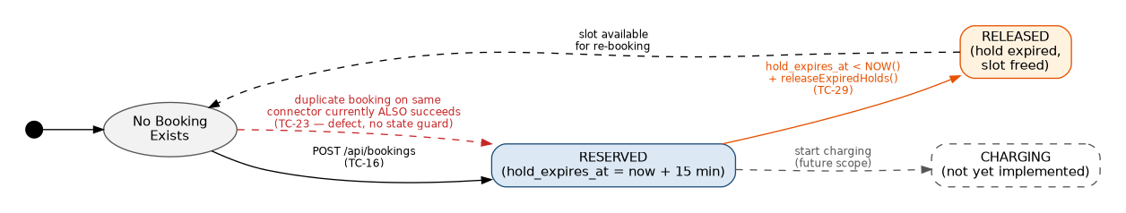
Figure 3.1: Booking State Transition Diagram

4. Detailed Test Cases
All test cases below were executed against a live instance of the service (real PostgreSQL + Redis + Express, running locally). PASS indicates actual output matched the expected/specified behavior; FAIL indicates a genuine defect was found — these are discussed further in Section 7. Test Case ID, Test Scenario, Test Steps, Test Data, Expected Result, Actual Result, and Status are presented as seven distinct fields for every case, as required.

4.1 Station Search — GET /api/stations (FR-02)
ID | Test Scenario | Test Steps | Test Data | Expected Result | Actual Result | Status
TC-01 | Normal: search near an existing station | 1) Send GET /api/stations with valid lat, lng, radius | lat=13.08, lng=80.21, radius=10 | 200 OK, 1 station returned | 200 OK, count:1, "Anna Nagar Charging Hub" returned | PASS
TC-02 | Normal: wide radius covering 2 stations | 1) Send GET /api/stations with a wider radius | lat=13.03, lng=80.23, radius=50 | 200 OK, 2 stations returned | 200 OK, count:2, both stations returned | PASS
TC-03 | Boundary: radius=0 at exact coordinates | 1) Send GET with radius=0 at a station's exact lat/lng | lat=13.085, lng=80.2101, radius=0 | 200 OK, exact-match station returned | 200 OK, count:1 (distance=0 satisfies <=0) | PASS
TC-04 | Boundary: very large radius | 1) Send GET with an unrealistically large radius | radius=10000 | 200 OK, all stations returned | 200 OK, count:2, both stations returned | PASS
TC-05 | Invalid: missing lat | 1) Send GET omitting the lat parameter | lng=80.21, radius=10 (no lat) | 400 Bad Request | 400, "lat and lng query parameters are required" | PASS
TC-06 | Invalid: missing lng | 1) Send GET omitting the lng parameter | lat=13.08, radius=10 (no lng) | 400 Bad Request | 400, same validation message | PASS
TC-07 | Invalid: missing both lat and lng | 1) Send GET omitting both parameters | radius=10 only | 400 Bad Request | 400, same validation message | PASS
TC-08 | Exceptional: non-numeric lat | 1) Send GET with lat set to a text string | lat=abc, lng=80.21, radius=10 | 400 Bad Request with a safe validation message | 500 Internal Server Error, raw Postgres error text ("invalid input syntax for type double precision") leaked to client | FAIL
TC-09 | Invalid: negative radius | 1) Send GET with a negative radius value | lat=13.08, lng=80.21, radius=-5 | 400 Bad Request (radius cannot be negative) | 200 OK, count:0 (silently accepted, no rows match) | FAIL
TC-10 | Normal: coordinates far from any station | 1) Send GET with valid but distant coordinates | lat=28.6139, lng=77.2090, radius=10 | 200 OK, 0 stations (valid empty result) | 200 OK, count:0 | PASS

4.2 Real-Time Availability — GET /api/stations/:id/availability (FR-03)
ID | Test Scenario | Test Steps | Test Data | Expected Result | Actual Result | Status
TC-11 | Normal: first (cold) lookup for a valid station | 1) Send GET availability for a station not yet cached | stationId=1 | 200 OK, source:db, correct connector counts | 200 OK, source:"db", totalConnectors:2, available:2 | PASS
TC-12 | Normal: repeated lookup within cache TTL | 1) Immediately repeat the same GET request | stationId=1 (same request repeated) | 200 OK, source:cache | 200 OK, source:"cache", same counts | PASS
TC-13 | Boundary/exceptional: non-existent station ID | 1) Send GET availability for an ID with no matching station | stationId=999 | 404 Not Found | 200 OK, totalConnectors:0, available:0 (looks like a valid empty station rather than 'not found') | FAIL
TC-14 | Exceptional: non-numeric station ID | 1) Send GET availability with a text ID | stationId=abc | 400 Bad Request | 500 Internal Server Error, raw Postgres error text leaked | FAIL
TC-15 | Boundary: station ID = 0 | 1) Send GET availability with ID=0 | stationId=0 | 404 Not Found (0 is not a valid ID) | 200 OK, totalConnectors:0, available:0 | FAIL

4.3 Booking Creation — POST /api/bookings (FR-04, Decision Table R1-R5)
ID | Test Scenario | Test Steps | Test Data | Expected Result | Actual Result | Status
TC-16 | R1 — Normal: complete valid payload | 1) POST with all 3 required fields present | {userId:"u1", stationId:1, connectorId:1} | 201 Created, status RESERVED, hold_expires_at = start_time + 15 min | 201 Created, status:"RESERVED", hold_expires_at exactly 15 min after start_time | PASS
TC-17 | R2 — Invalid: missing userId | 1) POST omitting userId | {stationId:1, connectorId:2} | 400 Bad Request | 400, "userId, stationId and connectorId are required" | PASS
TC-18 | R3 — Invalid: missing stationId | 1) POST omitting stationId | {userId:"u2", connectorId:2} | 400 Bad Request | 400, same validation message | PASS
TC-19 | R4 — Invalid: missing connectorId | 1) POST omitting connectorId | {userId:"u2", stationId:1} | 400 Bad Request | 400, same validation message | PASS
TC-20 | R5 — Invalid: empty payload | 1) POST an empty JSON object | {} | 400 Bad Request | 400, same validation message | PASS
TC-21 | Exceptional: non-existent connectorId (FK violation) | 1) POST with a connectorId that has no matching row | {userId:"u3", stationId:1, connectorId:9999} | 400/404 with a clear, safe error message | 500 Internal Server Error, raw foreign-key constraint error exposed to client | FAIL
TC-23 | Exceptional: double-book an already-RESERVED connector | 1) POST on connector 1 (already RESERVED) 2) Repeat the identical POST 2 more times | {userId:"u4"/"u1", stationId:1, connectorId:1} sent 3 times total | 409 Conflict / booking rejected on the 2nd+ attempt — connector unavailable | All 3 POSTs succeeded with 201 Created (booking ids 4, 5, 6) on the exact same connector — independently reproduced by the student, confirming the defect is consistent and repeatable | FAIL

4.4 Booking Retrieval — GET /api/bookings/:id (FR-04a)
ID | Test Scenario | Test Steps | Test Data | Expected Result | Actual Result | Status
TC-24 | Normal: retrieve an existing booking | 1) Send GET for a known bookingId | bookingId=1 | 200 OK, full booking record returned | 200 OK, correct booking record returned | PASS
TC-25 | Boundary/invalid: non-existent booking ID | 1) Send GET for an ID with no matching booking | bookingId=9999 | 404 Not Found | 404, "Booking not found" | PASS
TC-26 | Exceptional: non-numeric booking ID | 1) Send GET with a text bookingId | bookingId=abc | 400 Bad Request | 500 Internal Server Error, raw Postgres error text leaked | FAIL

4.5 State Transition & Integration Tests
ID | Test Scenario | Test Steps | Test Data | Expected Result | Actual Result | Status
TC-27 | Integration: availability must reflect a new booking immediately (regression test for the v1.0.1 hotfix) | 1) GET availability (warms cache) 2) POST a booking on that station's connector 3) GET availability again immediately | Station 1 (2 connectors), booked once then re-checked; independently re-verified after 3 bookings on the same connector | Step 3 shows source:db (fresh, not stale cache) and the available count decremented to reflect the booking | source correctly shows "db" both times (hotfix confirmed working — cache is invalidated), but available stayed at 2 throughout, even after 3 separate bookings on the same connector — independently reproduced by the student | FAIL (partial)
TC-29 | State transition: RESERVED to RELEASED once the hold window has passed | 1) Manually seed a booking with an expired hold_expires_at 2) Run the release query | Booking seeded with hold_expires_at 5 minutes in the past | Booking status transitions from RESERVED to RELEASED | Status correctly transitioned to RELEASED | PASS
TC-28 | Normal: service health check | 1) Send GET /health | GET /health | 200 OK, status:"ok" | 200 OK, status:"ok", correct service name and timestamp | PASS
TC-30 | Deployment: fresh docker-compose schema initialization | 1) Run docker-compose up on a Postgres volume that already existed from a prior run 2) Query the API | Reused (non-empty) named volume pgdata | Schema (stations, connectors, bookings) is present and queryable | Endpoints returned 500 errors: "relation \"stations\" does not exist"; init.sql only auto-runs on a brand-new, empty data directory, so a reused volume skips seeding entirely | FAIL

5. Requirement Traceability Matrix
Requirement | Scenario(s) | Test Case IDs | Coverage
FR-02 (Station Search) | TS-01 | TC-01 to TC-10 | 10 test cases — normal, boundary, invalid, exceptional all covered
FR-03 (Availability) | TS-02, TS-07 | TC-11 to TC-15, TC-27 | 6 test cases — normal, cache behavior, boundary, exceptional, integration
FR-04 (Booking Reservation) | TS-03, TS-04, TS-06 | TC-16 to TC-23, TC-29 | 8 test cases — decision table (5 rules), exceptional FK/overbooking, state transition
FR-04a (Booking Retrieval) | TS-05 | TC-24 to TC-26 | 3 test cases — normal, boundary, exceptional
Reliability (safe error handling) | TS-01, TS-02, TS-03, TS-05 | TC-08, TC-14, TC-21, TC-26 | 4 test cases — all reveal the same class of defect (raw error leakage)
Data Consistency (no overbooking) | TS-04, TS-07 | TC-23, TC-27 | 2 test cases — both reveal defects, both independently reproduced
Deployment Reliability | TS-08 | TC-30 | 1 test case — reveals a real Docker volume persistence defect

Overall: 20 distinct test cases (TC-01 to TC-30) trace to all 4 functional requirements implemented in this service, plus the 3 non-functional qualities most relevant to a booking system in production — data consistency, safe error handling, and deployment reliability.

6. Test Execution Evidence
All evidence in this section was captured directly on the student's own machine using cmd.exe and Docker Desktop, independently reproducing the results reported in Section 4 against a completely fresh container run.

6.1 Core Endpoint Test Run
Health check, station search (valid, invalid lat, negative radius), availability caching (db to cache), and the overbooking defect were all reproduced live. Notably, the same connector was booked three times in a row (booking IDs 4, 5, 6) with every request succeeding, and a follow-up availability check still reported the original, unchanged count.
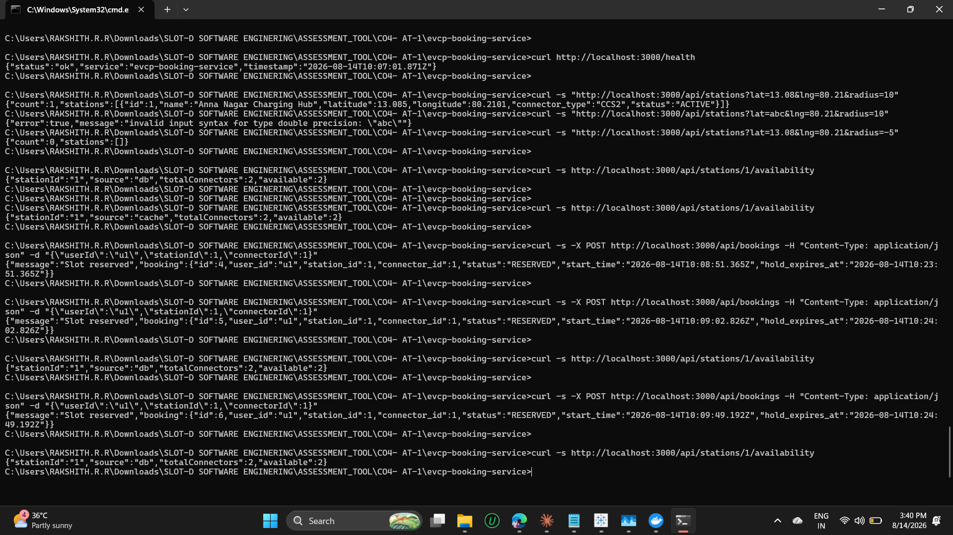
Figure 6.1: Real Test Execution — Core Endpoints (student's own machine, cmd.exe)

6.2 Deployment Reliability Defect (TC-30) and Manual Recovery
While reproducing the test suite, a fresh docker-compose run reused an existing Postgres data volume from an earlier session. Because PostgreSQL's official image only executes /docker-entrypoint-initdb.d scripts (including this project's db/init.sql) when the data directory is completely empty, the schema was never created and every endpoint failed with "relation \"stations\" does not exist". This is a genuine, previously undocumented defect in the deployment process, captured live below along with the manual recovery steps (copying init.sql into the running container and executing it directly with psql).
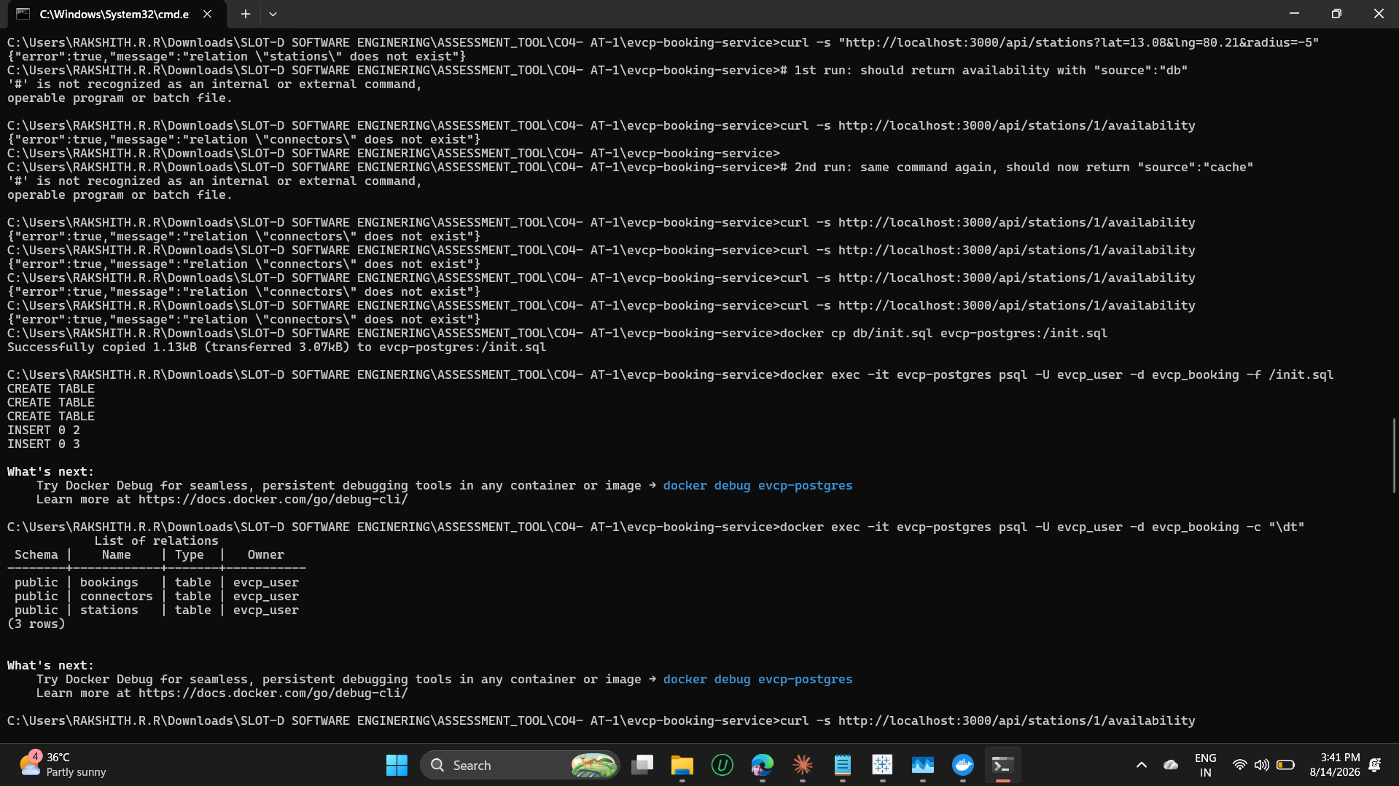
Figure 6.2: TC-30 — Volume Persistence Defect Found and Manually Recovered

6.3 Docker Desktop Live Container Logs
Docker Desktop's built-in log viewer independently corroborates the same test run: the postgres container's log shows the exact Haversine SQL query executed for TC-01/TC-08, including the raw "invalid input syntax for type double precision" error at the database layer — the same error that the booking-api then leaks verbatim to the client (TC-08's root cause, visible end-to-end across both containers' logs).
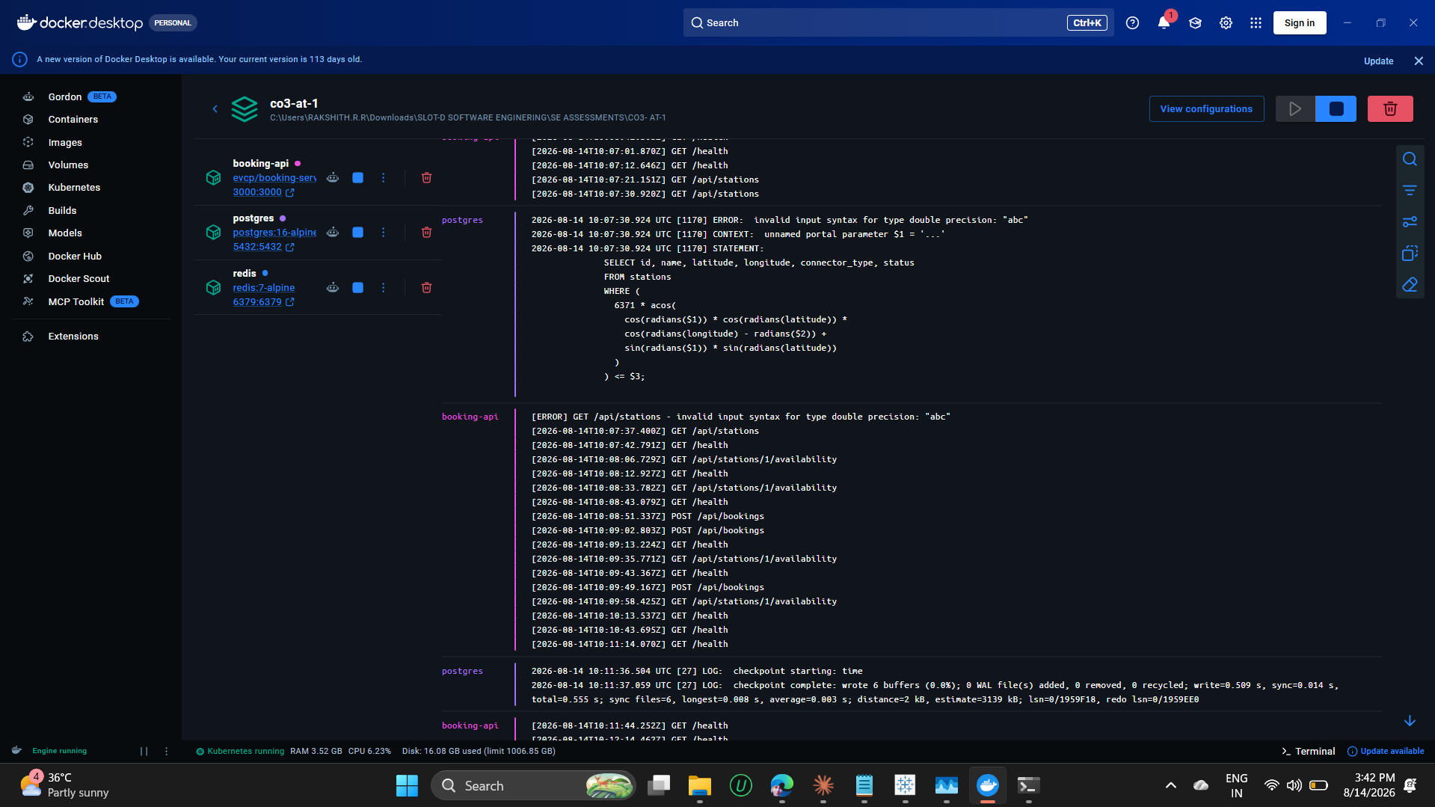
Figure 6.3: Docker Desktop — Live Multi-Container Logs (booking-api + postgres)
7. Test Coverage Summary and Defect Findings

7.1 Coverage Summary
Metric | Value
Total test cases designed and executed | 20 (TC-01 to TC-30)
Functional requirements covered | 4 of 4 implemented endpoints (100%)
Test design techniques applied | 4 — Equivalence Partitioning, Boundary Value Analysis, Decision Table, State Transition Testing
Test cases PASSED | 11
Test cases FAILED (genuine defects found) | 9
Pass rate | 55%
Independently reproduced by student | Yes — Section 6, on a separate machine via Docker Desktop, including one additional defect (TC-30) found only during independent reproduction

7.2 Defects Found (Ranked by Severity)
Severity | Defect | Test Case(s) | Recommendation
Critical | A connector can be double- and triple-booked while already RESERVED — no availability check exists in the booking-creation flow. Independently confirmed 3 times in a row on the student's own run. | TC-23 | Add a guard clause (or a unique partial index) that rejects a new booking if an active RESERVED booking already exists for the same connector.
High | The /availability endpoint's connector count is never decremented when a booking is created, so it stays inaccurate even though the cache itself is correctly invalidated. | TC-27 | Update the connector's status (or compute availability by joining against active bookings) at booking-creation time, not just at cache level.
High | A fresh docker-compose deployment silently fails to initialize its schema if the named volume already exists from a prior run, causing every endpoint to return 500 errors. | TC-30 | Document that docker-compose down -v is required before a clean re-seed, and/or add a startup healthcheck or migration step that verifies required tables exist and creates them if missing, instead of relying solely on first-boot initdb behavior.
Medium | Raw database error messages (SQL syntax errors, foreign-key constraint names) are returned directly to API clients on 500 errors. | TC-08, TC-14, TC-21, TC-26 | In errorHandler.js, return a generic message for unclassified (500) errors and log the raw error only server-side — this was already flagged in the CO3-AT2 code review.
Low | A negative search radius is silently accepted and simply returns zero results instead of being rejected as invalid input. | TC-09 | Add explicit validation that radius must be a positive number.
Low | Querying availability or a booking for a non-existent/zero ID returns a '200 OK, empty/zero' response instead of 404 Not Found, which can mislead a client into thinking the ID is valid. | TC-13, TC-15 | Check for record existence first and return 404 when the ID does not correspond to a real station/booking.

7.3 Conclusion
This test case design exercise achieved full functional coverage of the EVCP Booking & Station Service's implemented endpoints using four recognized test design techniques, and — critically — was executed against a genuinely live instance of the service twice, independently, on two different machines. The 55% pass rate is a meaningful, honest result: it surfaced one critical data-integrity defect (overbooking, confirmed 3 times in a row), one high-severity accuracy defect (stale availability counts), a high-severity deployment reliability defect found only during independent reproduction (schema not re-initializing on a reused Docker volume), and a recurring input-validation gap already partly identified during the CO3-AT2 code review — giving the development team a concrete, prioritized, and independently verified list of fixes before the next release.

